
Solution Architecture

Date | 30 June 2026
Team ID | SWUID2026213859
Project Name | Rising Waters
Maximum Marks | 5 Marks

Solution Architecture Diagram:
The solution architecture of the Rising Waters project illustrates the overall structure of the flood prediction system. It consists of a Presentation Layer for user interaction, a Flask-based Application Layer for request processing and machine learning prediction, and a Data Layer for storing datasets and trained models. This layered architecture ensures efficient data processing, accurate flood prediction, scalability, and easy maintenance of the application.
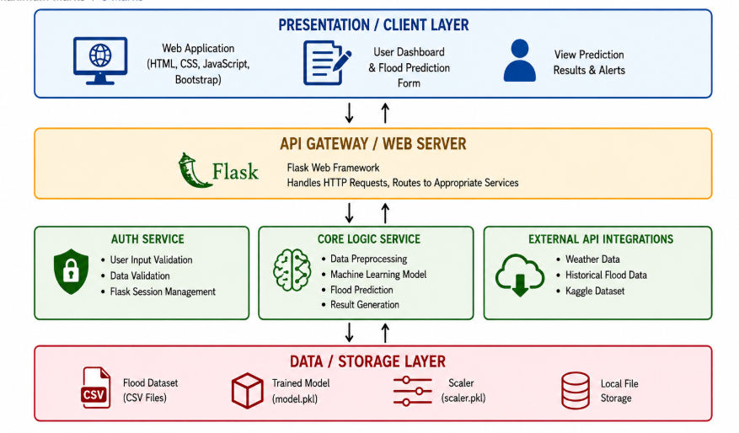


Component Description Table
